**SilenSwear: An Automatic English Swearword**

**Detection and Muting Using Keyword Spotting**

A Thesis

Presented to the Faculty of the

College of Computer and Information Sciences

Polytechnic University of the Philippines

In Partial Fulfilment

Of the Requirements for the Degree

Bachelor of Science in Computer Science

Medrano, Jamie Paul R.

Sefe, Marlon M.

March 2016

AUTHORIZATION

I/We hereby declare that I am/we are the sole author/s of the thesis.

I/We authorize the Polytechnic University of the Philippines and the College of Computer and Information Sciences to lend this thesis to other institutions or individuals for the purpose of scholarly research.

I/We further authorize the Polytechnic University of the Philippines and the College of Computer and Information Sciences to reproduce the thesis by photocopying or by other means, in total or in part, at the request of other institutions or individuals for the purpose of scholarly research.

______________________________

Medrano, Jamie Paul R.

______________________________

Sefe, Marlon M.

March 2016





The thesis **“SilenSwear: An Automatic English Swearword Detection and Muting Using Keyword Spotting”** submitted and presented by Medrano, Jamie Paul R., and Sefe, Marlon M. in partial fulfillment of the requirements for the degree of Bachelor of Science in Computer Science has been

Recommended for Approval and Acceptance: Date:

___________________________________ __________________

Dr. Vivien Iluminada R. Domingo

Faculty-In-charge

___________________________________ __________________

Prof. Ranil M. Montaril

Technical Advisor

Approved by the Thesis Defense Panel:

___________________________________ __________________

Prof. Carlo G. Inovero

___________________________________ __________________

Prof. Ranil M. Montaril

Accepted for the Department of Computer Science

___________________________________ __________________

Prof. Michael B. dela Fuente

Department Chairperson

Accepted for the College of Computer and Information Sciences

___________________________________ __________________

Prof. Gisela May A. Albano

Dean of the College

# ABSTRACT

This research is entitled “**SilenSwear: An Automatic English Detection and Muting Using Keyword Spotting**”. This system aimed to automatically detect and mute Hollywood Movie Clips. The collection of audios were gathered in various movie clips.

The researchers used formal experimental – randomized block design. The researchers used this because the block or group that was included in gathering training data and respondents were chosen distinctively to get an accurate result. To detect the swearwords from a movie clip, the researchers gathered different audios of swearwords from different Hollywood movies and used it as training data. There were twenty testing data that has length of ten seconds each. In this study, Keyword Spotting using Hidden Marcov Model was applied for detecting the swearwords in movie clips.

The findings of the study, indicates that the researchers have arrived on the following conclusions. Regarding on the accuracy rate in detecting swearwords from movie clips extracted from Hollywood films of 2013 with the most swears has an accuracy rate of 71.43%. Also, the reliability of the system is one (1) which is equivalent to excellent.

**ACKNOWLEDGEMENT**

The researchers would like to express their deepest gratitude to the following that without their help, this project would not be possible:

To the parents of the researchers, Medrano and Sefe family, who are always there with continuing support morally and financially.

To Ranil M. Montaril, MSECE, their technical adviser, who is always leading and helping the researchers in finishing this study.

To Renrick Gerald P. Igne, who have lent his hand throughout this research.

To the researcher’s friends and classmates, who gave their comments and suggestions on how to improve this study.

And most of all to Lord, who gave the researchers enough knowledge about this study, good health and wellbeing that were necessary to complete this research, and the perseverance and determination to continue doing this thesis in spite of the struggles that came the researchers’ way.

Table of Contents

ABSTRACT iii

List of Figures vii

List of Tables viii

Chapter 1: The Problem and Its Background 1

1.1 Introduction 1

1.2 Background of the Study 1

1.3 Conceptual Framework 3

1.3.1 Conceptual Framework of the System 3

1.3.2 Conceptual Framework of the Study 4

1.4 Statement of the Problem 4

1.5 Significance of the Study 5

1.6 Scope and Limitation 5

1.6.1 Scope and Limitation of the System 5

1.6.2 Scope and Limitation of the Study 6

1.7 Definition of Terms 6

Chapter 2: Review of Related Literature and Studies 8

2.1 Review of Related Literature 8

2.1.1 Impact of Swearword in Movies on A Child’s Mind 8

2.1.2 Capacity of a Child in Imitating 9

2.2 Review of Related Studies 9

2.2.1 Automatic Speech Recognition 9

2.2.2 Keyword Spotting 11

2.2.3 Pattern-matching Approach 11

2.2.4 Speech Recognition Using Hidden Marcov Model 12

2.2.5 Keyword Spotting Using Hidden Marcov Model 13

2.3 Synthesis of the Study 14

Chapter 3: Research Methodology 15

3.1 Research Method Used 15

3.2 Research Paradigm 15

3.3 System Architecture 16

3.3.1 Preprocessing 16

3.3.2 Main Process 16

3.3.3 Video with Muted Swearwords 17

3.4 Population Frame and Sample 17

3.5 Description of the Respondents 17

3.6 Sampling Technique 17

3.7 Instrumentation 18

3.8 Data Gathering Procedure 19

3.9 Statistical Treatment 19

3.9.1 Precision, Recall, and F-measure 19

3.9.2 Cronbach’s Alpha Test ($α$) 20

Chapter 4: Presentation, Analysis and Interpretation of data 22

4.1 Accuracy of the System 22

4.2 Reliability of the System 23

4.3 Reliability Statistics 23

Chapter 5: Summary of findings, Conclusion and Recommendation 24

5.1 Summary of findings 24

5.2 Conclusion 24

5.3 Recommendation 24

5.3.1 Context-Based Approach 25

5.3.2 Real Time Detection 25

REFERENCES 26

Appendix A 29

Appendix B 41

Appendix C 45

CURRICULUM VITAE 48

# List of Figures

[Figure 1.1 Conceptual Framework of the System 3](https://d.docs.live.net/9860edf0ac463815/Documents/Thesispaper_SilenSwear_rev-AJ.docx#_Toc448571741)

[Figure 1.2. Conceptual Framework of the Study 4](https://d.docs.live.net/9860edf0ac463815/Documents/Thesispaper_SilenSwear_rev-AJ.docx#_Toc448571742)

Figure 3.2 4th Generation Technique Paradigm 15

Figure 3.3 System Architecture……………….………………………………………………………………………..16

# List of Tables

Table 1.1 List of Swearwords 6

Table 4.1 Testing Results for Accuracy 21

Table 4.2 Testing Results for Reliability 22

Table 4.3 Reliability Statistics 22

Table A.1 Experiment Paper 23

Table A.2 Experiment Paper with Raw Data 25

Table B.1 Time Frame for Implementation 36

Chapter 1: The Problem and Its Background

1.1 Introduction

//intro

In the fast-paced modern world, where technology progresses rampantly. We tried to keep up with today’s trends as well as needs. //Today’s pace towards technology

//

1.2 Background of the Study

//background

Most Filipino shoppers have a hard time jumping to another store into other store just to find the best deals of their wanted product, may it be a new pair of shoes, shining jeans, or maybe a newly released branded cap. As much as we can, we bargain, bargain, and bargain, most modern Filipino women would go to mall after mall just to buy off on-sale product which is also true for old-fashion mothers who would prefer to bargain just to get deals from their market suppliers. In today’s technological advantage, many shopper prefer e-commerce as their mode of shopping [**Kitonyi**, 2017]. // problem in e-commerce, insert here bgots in slides

1.3 Conceptual Framework

1.3.1 Conceptual Framework of the System

// insert accuracy related concepts, input > user’s search terms, OSW. Process > search the terms at osw using data mining, filtering item to display the best deals. Output > Best deals.

1.3.2 Conceptual Framework of the Study

// remove this

1.4 Statement of the Problem

This study aims to develop a system that gets the best deal from various online shopping websites based on user’s search terms. // getting // finding out the deals, algo // accuracy of the results

1. Using the *algo1* algorithm, what is the accuracy of getting the relevant data from online shopping websites? // insert in conclusion, the percentage of accuracy.
2. How should the algo be devised in order to get the best deals out of the listed relevant product? And:
3. What is the accuracy of the devised *algo2* algorithm of getting the best deals?
4. What is the reliability of the algorithm in getting the right best deals?

3. // User experience related shit.

1.5 Significance of the Study

The system will benefit the following people:

Online Shoppers. This study would benefit shoppers who wants to lessen their time on selecting the best deal.

Store Owners. This will benefit them by being able to search how they would price their own products.

Future Researchers. This study will be a help as a guiding reference in making a system related to e-commerce.

1.6 Scope and Limitation

1.6.1 Scope and Limitation of the System

The system will mine data from most used retailer online shopping websites specifically:

//list ng websites

The system won’t include second hand online shopping websites.

1.6.2 Scope and Limitation of the Study

This study will focus on the accuracy of the finding the best deals of a product selected by the user at the top online shopping websites.

1.7 Definition of Terms

**Data Mining**

**Online Shopping Websites -**

**Reference -** https://www.gurufocus.com/news/490164/ecommerce-is-killing-traditional-retail

Chapter 2: Review of Related Literature and Studies

2.1 Review of Related Literature

2.1.1 Impact of Swearword in Movies on A Child’s Mind

Sangeeta Danhay Chaubal said that watching movies has known to have both positive as well as negative impact on a child's mind as well on his overall development. The author also said that movies with social message or pure fun can be worth watching but movies with too much of violence and mean messages are of no good to children[Chaubal].

Ronald E. Riggio Ph.D. said that it is clear that swearing can take form of verbal abuse and harassment, and it is this sort of swearing that can be potentially harmful- a substitute for physical aggression. According to the researcher hearing swear words in a movie or TV show or on playground harm children not because of swearing itself but the factors associated with swearing[Riggio 2012].

"Because many films transmit ideas through emotion rather than intellect, they can neutralize the instinct to suppress feelings and trigger emotional release,” said Birgit Wolz, a psychologist focusing on movies as therapy, and author of E-motion Picture Magic [Braff 2011].

According to Dr. Diane Howard, family sitting down to watch a movie is shot with paintballs every time a swear word is uttered on screen. Every word has impact [Howard 2013].

2.1.2 Capacity of a Child in Imitating

A Child developmental capacity for abstraction is a crucial factor in appreciating his or her capacity to understand a movie. A related but separate factor is the child's capacity for moral reasoning. Jean Piaget discovered that children younger than eight or nine had trouble judging people on their intentions. Rather, when read hypothetical stories, younger children would judge people on the final outcome of their actions [Minnow 2014].

Children often like to try out words they hear or make up. And these are just as likely to be swear words as others. Children pick up swear words from many sources, outside and inside the home. Not all children learn swear words from their parents. Research suggests that exposure to swear words on **TV** can lead to an increase in swearing in children [Green, Julie; 2015].

 Around the age of 5 or 6, most kids get a big thrill out of potty language like “hello, Captain Underpants!” or any word that gets a rise out of parents. This age is a great time to help kids understand that there are places where certain language is OK but not in. What kids intuitively understand is that words are powerful, and certain words make a big impact. [Filucci 2011]

**2.2 Review of Related Studies**

2.2.1 Automatic Speech Recognition

Automatic speech recognition is the process by which a computer maps an acoustic speech signal to text. A speaker independent system is developed to operate for any speaker of a particular type [cmu.edu]. To recognize speech, the waveform must be taken, split on utterances by silences then try to recognize what's being said in each utterance. The model of speech is called Hidden Markov Model (HMM), a model that has been proven to be really practical for speech decoding[CMUSphinx 2015].

Automatic continuous speech recognition (ACSR) has many potential applications including command and control, dictation, transcription of recorded speech, searching audio documents and interactive spoken dialogues. The core of all speech recognition systems consists of a set of statistical models representing the various sounds of the language to be recognized. Since speech has temporal structure and can be encoded as a sequence of spectral vectors spanning the audio frequency range, the hidden Markov model (HMM) provides a natural framework for constructing such models[Eagon].

According to Mr. Mark Gales and Mr. Steve Young, automatic continuous speech recognition (CSR) has many potential applications including command and control, dictation, transcription of recorded speech, searching audio documents and interactive s llkpoken dialogues. The core of all speech recognition systems consists of a set of statistical models representing the various sounds of the language to be recognized.[Gales and Young 2007]

According to Aren Jansen and Partha Niyogi, investigating the speech recognition task of spotting predefined keywords in continuous speech has both practical and scientific motivations. Keyword spotting (KWS) is a technologically relevant problem, playing an important role in audio indexing and speech data mining applications. It is also a task that humans perform with astonishing ease, even in situations where little access to non-lexical linguistic constraints is provided (e.g., spotting native words in an unfamiliar language).[Jansen and Niyogi 2009]

2.2.2 Keyword Spotting

According to the researchers Jan Nouza and Jan Silovsky, Keyword spotting (KWS) has become an important branch of speech technology. It is applied mainly in situations where a large amount of spoken documents must be searched to learn whether they contain some specific words. The fast detection of these words (and information about their exact location) eliminates a lot of human work in such tasks like audio data mining, named entity search, and, in particular, in the state security domain. [Nouza and Silovsky 2009]

According to Vibha Tiwari, the extraction and selection of the best parametric representation of acoustic signals is an important task in the design of any speech recognition system; it significantly affects the recognition performance. A compact representation would be provided by a set of mel-frequency cepstrum coefficients, which are the results of a cosine transform of the real logarithm of the short-term energy spectrum expressed on a mel-frequency scale.[Vibha 2010]

2.2.3 Pattern-matching Approach

The pattern-matching approach involves two essential steps namely, pattern training and pattern comparison. The essential feature of this approach is that it uses a well formulated mathematical framework and establishes consistent speech pattern representations, for reliable pattern comparison, from a set of labelled training samples via a formal training algorithm. A pattern recognition has been developed over two decade received much attention and applied widely too many practical pattern recognition problem. A speech pattern representation can be in the form of a speech template or a statistical model (e.g., a HIDDEN MARKOV MODEL or HMM) and can be applied to a sound (smaller than a word), a word, or a phrase. In the pattern comparison stage of the approach, a direct comparison is made between the unknown speeches (the speech to be recognized) with each possible pattern learned in the training stage in order to determine the identity of the unknown according to the goodness of match of the patterns. The pattern-matching approach has become the predominant method for speech recognition in the last six decades [Madisetti 2010].

2.2.4 Speech Recognition Using Hidden Marcov Model

According to Srinivasan, Hidden Markov Models (HMMs) are widely used in pattern recognition applications, most notably speech recognition. Speech samples are recorded using a wave surfer tool. Wave surfer is a simple but powerful interface. The sound can be visualized and analyzed in several ways with the help of this tool. The recorded signal (test data) is compared with the original signal (trained data) using Hidden Markov Model algorithms. This speech recognition is simulated in Matlab. Stochastic processes that are usually presented as having a finite set of states, but which, in another sense, may have an infinite number of states. These processes are known variously as Hidden Markov Models (HMMs), functions of a Markov Chain, or stochastic finite automata, all of which are essentially equivalent. HMMs are used most widely and will be used here. A process in the HMM class can be described as a finite-state Markov Chain with a memory less output process which produces symbols in a finite alphabet. This is the sense in which these processes have finitely many states. However, from the perspective of an observer who knows the parameters of some representation of the process and is able to observe the output symbols but not the internal states, things look different. For some processes there are infinitely many distinct states of such an observer’s knowledge about the status of the process. This knowledge is defined in terms of conditional distributions on future symbols. This is the sense in which there can be infinitely many states. These states are more relevant than the original finite set of states to the study of the process, since they allow for optimal prediction [Srinivasan 2011].

According to Sevket Duran, Speech recognition is the process of converting digital speech signal into words. To capture speech signal we need a device that converts physical speech wave into digital signal. This may be a microphone that converts the speech into analog signal and a sound card that is an A/D converter that converts the analog signal to the digital signal. Another way of obtaining digital speech input is to use a telephone card that converts the analog 6 signal that comes from the telephone line into digital signal [Duran 2001].

2.2.5 Keyword Spotting Using Hidden Marcov Model

Based on Sevket Duran for speech recognition, the digitized speech signal that is in the time domain must be transformed into another domain. Generally some part of the speech is taken and a feature vector is derived to represent that part. Next these feature vectors are used to guess the sequence of words that generated this speech signal. We need algorithms that account for the variability in the speech signal. The most common technique for acoustic modeling is called hidden Markov modeling (HMM). The main difficulty of the speech recognition problem comes from the variability of the source of the signal. First, the characteristics of phonemes, the smallest sound units, are dependent on the context in which they appear [Duran 2001].

2.3 Synthesis of the Study

Modern films or movies increase every year. Children are attracted to it and sometimes parents do not think about the content of the movies that their children are watching. As children watch movies, they cannot avoid to hear the swearwords in the movies they watch. According to researchers, there’s always a negative impact when children hear bad words or swearwords as these can cause them to become aggressive.

Researchers also said that hearing swear words in a movie or TV show or on playground harm children not because of swearing itself but the factors associated with swearing. Therefore, systems that can filter or mute swearwords in movies are necessary and parents can avoid their children from speaking and learning swearwords.

Chapter 3: Research Methodology

3.1 Research Method Used

SilenSwear: An Automatic English Swearword Detection and Muting Using Keyword Spotting was designed with formal experimental – randomized block design. The researchers used this because the block or group that was included in gathering training data and respondents were chosen distinctively to get an accurate result.

3.2 Research Paradigm

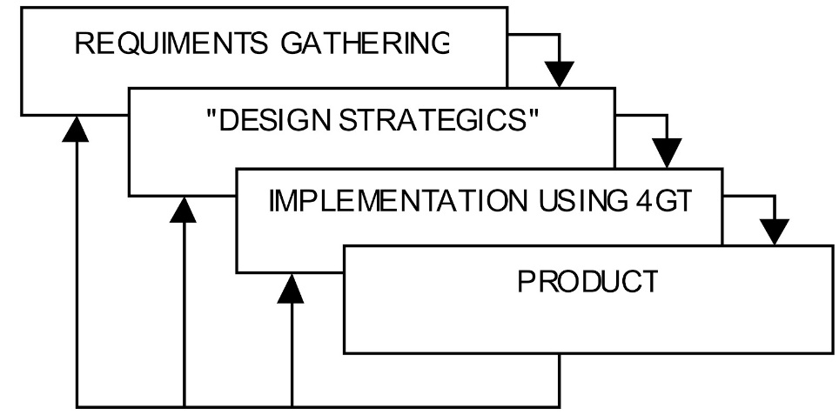

Figure 3.2 4th Generation Technique Paradigm

The Research Paradigm that the researchers used is 4th Generation Technique Paradigm. The researchers will conduct testing of the system and develop documentations and perform solution integration activities that are required.

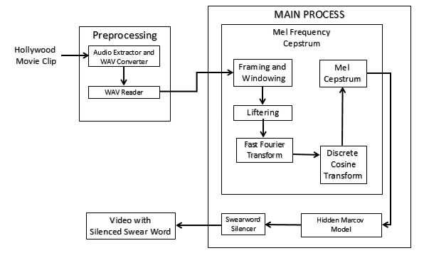3.3 System Architecture

Figure 3.3 System Architecture

3.3.1 Preprocessing

The audio layer of the movie clip will be extracted and converted into a WAV file. The WAV reader will convert the audio from analog to digital.

3.3.2 Main Process

The detected voiced signals are segmented and the Mel-Frequency Cepstral Coefficient method (MFCC) is applied to all of the segmented windows. The MFCC feature vectors will now be decoded with Keyword Spotting using Hidden Markov Model. Then the swearwords detected will then be silenced.

3.3.3 Video with Muted Swearwords

The system will generate an MP4 video with muted swearwords. If no swearwords are detected, the system will not generate a new video.

3.4 Population Frame and Sample

The population of the study consists of top 50 Hollywood movies of 2013 with most f-words based on the movie rating site kids-in-mind.com. The sampling size of the study is 20 Hollywood movie clips from the top 50 Hollywood movies with most f-words.

3.5 Description of the Respondents

The respondents for this study are the researchers. The researchers gathered and used swearwords audio files extracted from movies to train the system. The researchers then evaluated the accuracy and reliability of the system.

3.6 Sampling Technique

The Sampling Technique used by the researchers is Purposive Sampling Technique. Purposive sampling is also known as Judgmental, selective or subjective sampling. This study aims to develop a system that detects and mutes swearwords of movie clips. The researchers selected Movies from 2013 Hollywood Movies with most F-words based on the movie rating site kids-in-mind.com and used it for testing.

3.7 Instrumentation

The researchers used C# programming language to develop the system. The system developed accepts a video input in an mp4 file format. It then extracts the audio from the video input and the audio is then analyzed for swearword detection using Mel-Frequency Cepstrum Coefficient (MFCC) and Hidden Markov Model (HMM). The system generates an mp4 video with muted swearwords. An experiment paper was used to determine the system’s accuracy and reliability

The experiment paper consists of nine (9) columns namely Clip, Input, Detected, TP, FP, FN, Precision, Recall, and F-measure. The Clip column contains the number that identifies the particular video clip that was used in testing the system. The Input column contains the equivalent text of the speech contained in the input video clip. The Detected column contains the equivalent text of the speech contained in the output video clip. The TP column contains the number of true positives or swearwords correctly detected. The FP column contains the number of false positives or words incorrectly detected as swearwords. The FN column contains the number of false negatives or swearwords that are not detected. The Precision column contains the percentage of the swearwords correctly detected out of the total detected swearwords. Precision is computed using the formula of precision in 3.9 Statistical Treatment. The Recall column contains the percentage of the swearwords correctly detected out of the total of all swearwords. Recall is computed using the formula of precision in 3.9 Statistical Treatment. The F-measure column contains the accuracy of the system in detecting swearwords in the particular video clip. F-measure is computed using the formula of precision in 3.9 Statistical Treatment.

Each video clip is repeated three times, thus each video clip has three F-measure values. The Chronbach’s Alpha is computed using the F-measure values of each video clip as inputs in Statistical Package for the Social Science (SPSS). The system’s reliability is determined by the computed alpha as shown in 3.9 Statistical Treatment.

3.8 Data Gathering Procedure

This section of the paper elaborates the procedure that the researchers used in gathering data.

The researchers used extracted swearwords from different Hollywood movies, other than the ones used in testing, and used it for training the system.

The top 50 Hollywood movies of 2013 with most f-words based on the movie rating site kids-in-mind.com were selected for testing the system. The researchers gathered 20 Hollywood movie clips from the top 50 Hollywood movies with most f-words

## 3.9 Statistical Treatment

### 3.9.1 Precision, Recall, and F-measure

Precision = $\frac{tp }{tp+fp}$* 100%

Formula for Precision

The formula for precision is the ratio of the swearwords that are correctly detected to the total swearwords that are correctly detected and words that are incorrectly detected as swearwords.

Recall = $\frac{tp }{tp+fn}$* 100%

Formula for Recall

The formula for recall is the ratio of the swearwords that are correctly detected to the total of all swearwords correctly detected and swearwords that are not detected.

F-measure (%) = 2 * ( $\frac{precision*recall }{precision+recall}$) * 100%

Formula for F-measure

The F-measure was used to compute for the accuracy of the system in detecting swear words.

Where: *tp =* true positive, swearwords that are correctly detected

*fp =* false positive, words incorrectly detected as swearwords

*fn* = false negative, swearwords that are not detected

### 3.9.2 Cronbach’s Alpha Test ($α$)

Basis for determining for the reliability of the system using Statistical Package for the Social Science (SPSS).

Excellent = greater than 0.9 Questionable = greater than 0.6

Good = greater than 0.8 Poor = greater than 0.5

Acceptable = greater than 0.7 Unacceptable = less than 0.5

The reliability coefficient of .70 or higher is considered as “acceptable” in most social science research situation.

Chapter 4: Presentation, Analysis and Interpretation of data

The purpose of this study was to develop a system that detects and mute swearwords in a movie clip. This chapter provided the gathered data and researchers’ analysis and interpretation of the testing results.

As stated from the first chapter, the following were the gathered data which answers the said statements:

4.1 Accuracy of the System

Table 4.1 Testing Results for Accuracy

|  |  |  |  |  |  |  |
| --- | --- | --- | --- | --- | --- | --- |
| **Number of Movie Clips** | **TP** | **FP** | **FN** | **Precision** | **Recall** | **F-measure** |
| 20 | 195 | 123 | 33 | 61.32% | 85.53% | 71.43% |

As presented in Table 4.1, the researchers used 20 movie clips as testing data in this study. From all the movie clips, there were 195 swear words correctly detected by the system, and 123 words were detected incorrectly by the system. Thirty three of the words were incorrectly rejected by the system. With the following data, the accuracy of the system in detecting swear words is 71.43%. Its precision is 61.32%, and with 85.43% recall.

4.2 Reliability of the System

Table 4.2 Testing Results for Reliability

|  |  |  |  |
| --- | --- | --- | --- |
| **Movie Clip** | **Trial 1** | **Trial 2** | **Trial 3** |
| 1 | 85.714 | 85.714 | 85.714 |
| 2 | 75.000 | 75.000 | 75.000 |
| 3 | 66.667 | 66.667 | 66.667 |
| 4 | 66.667 | 66.667 | 66.667 |
| 5 | 75.000 | 75.000 | 75.000 |
| 6 | 85.714 | 85.714 | 85.714 |
| 7 | 72.727 | 72.727 | 72.727 |
| 8 | 66.667 | 66.667 | 66.667 |
| 9 | 60.000 | 60.000 | 60.000 |
| 10 | 71.429 | 71.429 | 71.429 |
| 11 | 66.667 | 66.667 | 66.667 |
| 12 | 85.714 | 85.714 | 85.714 |
| 13 | 80.000 | 80.000 | 80.000 |
| 14 | 66.667 | 66.667 | 66.667 |
| 15 | 53.333 | 53.333 | 53.333 |
| 16 | 83.333 | 83.333 | 83.333 |
| 17 | 66.667 | 66.667 | 66.667 |
| 18 | 60.000 | 60.000 | 60.000 |
| 19 | 72.727 | 72.727 | 72.727 |
| 20 | 88.889 | 88.889 | 88.889 |

Each movie clip was tested 3 times, Table 4.2 shows that in every trial, the accuracy of the system was consistent proving that it is consistent.

4.3 Reliability Statistics

Table 4.3 Reliability Statistics

|  |  |  |
| --- | --- | --- |
| **Cronbach’s Alpha** | **Cronbach’s Alpha Based on Standardized Items** | **N of Items** |
| 1.000 | 1.000 | 3 |

As presented in table 4.3, the alpha coefficient for the 3 items is 1.000 suggesting that the items have relatively internal consistency.

Chapter 5: Summary of findings, Conclusion and Recommendation

5.1 Summary of findings

The questions for this study were: (1) what is the accuracy of the system in detecting swear words? (2) What is the reliability of the system in detecting swear words?

The accuracy of the system in identifying swear words of movie clips and recommendation were tested by the researchers. The generated outputs were evaluated by the researchers. With the data gathered, the system’s accuracy was 71.43%. The reliability of the system in detecting swearwords of movie clips were tested by the system. In every trial the system gives consistent values and based on the reliability analysis of the testing results using Statistical Package for the Social Science (SPSS) the alpha coefficient is 1.000 suggesting that the items have relatively internal consistency.

5.2 Conclusion

The findings of the study, indicates that the proponents have arrived on the following conclusions. Regarding on the accuracy rate in detecting swearwords from movie clips extracted from Hollywood films of 2013 with the most swears has an accuracy rate of 71.43%. Also, the reliability of the system is one (1) which is equivalent to excellent.

5.3 Recommendation

Several potential directions of research can be identiﬁed from this work.

5.3.1 Context-Based Approach

In its current structure, our keyword spotter relies on a sequence of phonemes without considering the neighboring context. It would be of a great interest to improve the results from the use of phonemes in context.

5.3.2 Real Time Detection

Our system first detects swearwords then generates a new video with muted swearwords, before users can watch the video. It is recommended to make the system detect swearwords in real time so there would be less time consumed in waiting before the system is finished analyzing the whole video.

# **REFERENCES**

x

|  |  |
| --- | --- |
| [Agence France-Presse 2012] | AGENCE FRANCE-PRESSE. 2012. Philippine film industry decline. from *Inquirer.net*: http://entertainment.inquirer.net/30455/philippine-film-industry-in-decline |
| [Braff 2011] | Braff, Daniel. Movies may cause special effects on the body (June 2011). |
| [Chaubal] | Chaubal, Sangeeta Danhay. How watching movies impact children. |
| [cmu.edu] | CMU.EDU. What is speech recognition? from *Carnegie Mellon University*: http://www.speech.cs.cmu.edu/comp.speech/Section6/Q6.1.html |
| [CMUSphinx 2015] | CMUSPHINX. 2015. Basic Concepts of Speech. from *CMUSphinx*: http://cmusphinx.sourceforge.net/wiki/tutorialconcepts |
| [Daily Mail] | DAILY MAIL. Too much bad language on TV. from *Daily Mail Online*: http://www.dailymail.co.uk/tvshowbiz/article-188713/Too-bad-language-TV.html |
| [Duran 2001] | Duran, Sevket. *Keyword Spotting Using Hidden Markov Model*. Boğaziçi University, 2001. |
| [Eagon] | Eagon, L. E. Baum and J. A. An inequality with applications to statistical. *Bulletin of American Mathematical Society*, 73, 360-363. |
| [Filucci 2011] | Filucci, Sierra. 2011. 5 Ways to Talk to Your Kids About Swearing -- and Why. from *Common Sense Media*: https://www.commonsensemedia.org/blog/5-ways-to-talk-to-your-kids-about-swearing-and-why# |
| [Gales and Young 2007] | Gales, Mark and Young, Steve. *The Application of Hidden Markov Models in Speech Recognition*. Foundations and Trends in Signal Processing, 2007. |
| [Green, Julie; 2015] | GREEN, JULIE. 2015. Swearing: toddlers and preschoolers. from *raisingchildren.net.au*: http://raisingchildren.net.au/articles/swearing_toddlers_preschoolers.html |
| [Howard 2013] | Howard, Diane. 2013. A Media-Wise Report on Foul Language. from *Movie Guide*: http://www.movieguide.org/news-articles/media-wise-report-foul-language.html |
| [Jansen and Niyogi 2009] | Jansen , Aren and Niyogi , Partha. Point Process Models for Spotting Keywords. *IEEE TRANSACTIONS ON AUDIO, SPEECH, AND LANGUAGE PROCESSING*, 17, 8 (NOVEMBER 2009). |
| [Madisetti 2010] | Madisetti, Vijay K. *The Digital Signal Processing Ha*. CRC Press, 2010. |
| [Minnow 2014] | Minnow, Nell. *The Movie Mom's Guide to Family Movies 2nd Edition*. 2014. |
| [Nouza and Silovsky 2009] | Nouza, Jan and Silovsky, Jan. *Fast Keyword Spotting in Telephone Speech*. RADIOENGINEERING, 2009. |
| [Park 2011] | Park, Alice. 2011. Children Who Hear Swear Words on TV Are More Aggressive. from *Time*: http://healthland.time.com/2011/10/17/children-who-hear-swear-words-on-tv-are-more-aggressive/ |
| [Riggio 2012] | Riggio, Ronald E. Will Swearing Harm your Child? (May 2012). |
| [Srinivasan 2011] | Srinivasan, A. Speech recognition using Hidden Marcov Model. *Applied Mathematical Sciences 3943 - 3948*, 5 (May 2011). |
| [TVGuardian 2015] | TVGUARDIAN. 2015. The TVGuardian Mutes Foul Language From TV Shows and Movies. from *TVGuardian*: http://www.tvguardian.com/ |
| [Vibha 2010] | Vibha, Tiwari. *MFCC and its application in speaker recognition*. International Journal on Emerging Technologies, India, 2010. |
| [VidAngel Inc. 2013] | VIDANGEL INC. 2013. Hollywood vs. YouTube. from *VidAngel*: https://www.vidangel.com/hollywood-vs-youtube/swearing/ |
| [Warner 2014] | Warner, Russ. 2014. Too Much Profanity in Movies? There’s a Great New Solution. from *Net Nanny*: https://www.netnanny.com/blog/too-much-profanity-in-movies-theres-a-great-new-solution/ |
| [Watts 2012] | Watts, Gregory. 2012. Remove The Curse Words. from *Videomaker*: http://www.videomaker.com/community/forums/topic/remove-the-curse-words |

x

# Appendix A

Appendix A. Experiment Paper

Table A.1 Experiment Paper

|  |  |  |  |  |  |  |  |  |
| --- | --- | --- | --- | --- | --- | --- | --- | --- |
| Clip | Input | Detected | TP | FP | FN | Precision | Recall | F-measure |
| 1 |  |  |  |  |  |  |  |  |
|  |  |  |  |  |  |  |
|  |  |  |  |  |  |  |
| 2 |  |  |  |  |  |  |  |  |
|  |  |  |  |  |  |  |
|  |  |  |  |  |  |  |
| 3 |  |  |  |  |  |  |  |  |
|  |  |  |  |  |  |  |
|  |  |  |  |  |  |  |
| 4 |  |  |  |  |  |  |  |  |
|  |  |  |  |  |  |  |
|  |  |  |  |  |  |  |
| 5 |  |  |  |  |  |  |  |  |
|  |  |  |  |  |  |  |
|  |  |  |  |  |  |  |
| 6 |  |  |  |  |  |  |  |  |
|  |  |  |  |  |  |  |
|  |  |  |  |  |  |  |
| 7 |  |  |  |  |  |  |  |  |
|  |  |  |  |  |  |  |
|  |  |  |  |  |  |  |
| 8 |  |  |  |  |  |  |  |  |
|  |  |  |  |  |  |  |
|  |  |  |  |  |  |  |
| 9 |  |  |  |  |  |  |  |  |
|  |  |  |  |  |  |  |
|  |  |  |  |  |  |  |
| 10 |  |  |  |  |  |  |  |  |
|  |  |  |  |  |  |  |
|  |  |  |  |  |  |  |
| 11 |  |  |  |  |  |  |  |  |
|  |  |  |  |  |  |  |
|  |  |  |  |  |  |  |
| 12 |  |  |  |  |  |  |  |  |
|  |  |  |  |  |  |  |
|  |  |  |  |  |  |  |
| 13 |  |  |  |  |  |  |  |  |
|  |  |  |  |  |  |  |
|  |  |  |  |  |  |  |
| 14 |  |  |  |  |  |  |  |  |
|  |  |  |  |  |  |  |
|  |  |  |  |  |  |  |
| 15 |  |  |  |  |  |  |  |  |
|  |  |  |  |  |  |  |
|  |  |  |  |  |  |  |
| 16 |  |  |  |  |  |  |  |  |
|  |  |  |  |  |  |  |
|  |  |  |  |  |  |  |
| 17 |  |  |  |  |  |  |  |  |
|  |  |  |  |  |  |  |
|  |  |  |  |  |  |  |
| 18 |  |  |  |  |  |  |  |  |
|  |  |  |  |  |  |  |
|  |  |  |  |  |  |  |
| 19 |  |  |  |  |  |  |  |  |
|  |  |  |  |  |  |  |
|  |  |  |  |  |  |  |
| 20 |  |  |  |  |  |  |  |  |
|  |  |  |  |  |  |  |
|  |  |  |  |  |  |  |
|  | | Total |  |  |  |  |  |  |

Table A.2 Experiment Paper with Raw Data

|  |  |  |  |  |  |  |  |  |
| --- | --- | --- | --- | --- | --- | --- | --- | --- |
| Clip | Input | Detected | TP | FP | FN | Precision | Recall | F-measure |
| 1 | And you as well. I see you've already met the village asshole. Smile and dial. And don't pick up your fucking head until 1:00. Hey, fuck him. I'm the senior broker here. He's just a worthless piker. (Wolf Of Wall Street) | And you as well. I see you've already met the village SWEAR and dial. And don't pick up SWEAR head until 1:00. Hey, SWEAR. I'm the senior broker here. He's just a worthless piker. | 3 | 1 | 0 | 75 | 100 | 85.714286 |
| And you as well. I see you've already met the village SWEAR and dial. And don't pick up SWEAR head until 1:00. Hey, SWEAR. I'm the senior broker here. He's just a worthless piker. | 3 | 1 | 0 | 75 | 100 | 85.714286 |
| And you as well. I see you've already met the village SWEAR and dial. And don't pick up SWEAR head until 1:00. Hey, SWEAR. I'm the senior broker here. He's just a worthless piker. | 3 | 1 | 0 | 75 | 100 | 85.714286 |
| 2 | Oh, my God, if I don't fuck Michael Cera tonight, I'm gonna blow my brains out. What? Fucking pale, 110 pounds, hairless, probably has a huge cock, coked out of his mind... You can do a lot better. (This Is The End) | Oh, my God, if I SWEAR Cera tonight, I'm gonna blow my brains out. What? SWEAR pale, 110 pounds, hairless, probably has a huge SWEAR, coked out of his mind... You can do a lot better. | 3 | 2 | 0 | 60 | 100 | 75 |
| Oh, my God, if I SWEAR Cera tonight, I'm gonna blow my brains out. What? SWEAR pale, 110 pounds, hairless, probably has a huge SWEAR, coked out of his mind... You can do a lot better. | 3 | 2 | 0 | 60 | 100 | 75 |
| Oh, my God, if I SWEAR Cera tonight, I'm gonna blow my brains out. What? SWEAR pale, 110 pounds, hairless, probably has a huge SWEAR, coked out of his mind... You can do a lot better. | 3 | 2 | 0 | 60 | 100 | 75 |
| 3 | Oh, shit, Randy! He's got a gun, Randy! I'm scared, Randy. Give me your fucking phone, Randy! Put the fucking gun away, OK? No, dude, you know what? I know guns. That shit ain't even real. Huh? Is this real? (21 & Over) | SWEAR, Randy! He's got a gun, Randy! I'm scared, Randy. Give me your SWEAR, Randy! Put SWEAR away, OK? No, dude, you know what? I know guns. SWEAR even real. Huh? Is this real? | 4 | 4 | 0 | 50 | 100 | 66.666667 |
| SWEAR, Randy! He's got a gun, Randy! I'm scared, Randy. Give me your SWEAR, Randy! Put SWEAR away, OK? No, dude, you know what? I know guns. SWEAR even real. Huh? Is this real? | 4 | 4 | 0 | 50 | 100 | 66.666667 |
| SWEAR, Randy! He's got a gun, Randy! I'm scared, Randy. Give me your SWEAR, Randy! Put SWEAR away, OK? No, dude, you know what? I know guns. SWEAR even real. Huh? Is this real? | 4 | 4 | 0 | 50 | 100 | 66.666667 |
| 4 | They turn into more sluts. Fuck it. Give me a whiskey. I just noticed that lion, that lion. It's just... that is amazing. Fuck, who the fuck keeps putting lions (The Heat) | They turn into more sluts. SWEAR. Give me a whiskey. I just noticed that lion, that lion. It's just... that is amazing. SWEAR, who the SWEAR keeps putting lions | 2 | 1 | 1 | 66.66667 | 66.67 | 66.666667 |
| They turn into more sluts. Fuck it. Give me a whiskey. I just noticed that lion, that lion. It's just... that is amazing. Fuck, who the fuck keeps putting lions | 2 | 1 | 1 | 66.66667 | 66.67 | 66.666667 |
| They turn into more sluts. Fuck it. Give me a whiskey. I just noticed that lion, that lion. It's just... that is amazing. Fuck, who the fuck keeps putting lions | 2 | 1 | 1 | 66.66667 | 66.67 | 66.666667 |
| 5 | Fuck that. Don't be such a fucking pussy. No, man. It's over. Can't do it. Won't do it. You made your fucking choice. (The Place Beyond the Pines) | Fuck that. Don't be such SWEAR, man. It's over. Can't do it. Won't do it. You made your SWEAR choice. | 3 | 2 | 0 | 60 | 100 | 75 |
| Fuck that. Don't be such SWEAR, man. It's over. Can't do it. Won't do it. You made your SWEAR choice. | 3 | 2 | 0 | 60 | 100 | 75 |
| Fuck that. Don't be such SWEAR, man. It's over. Can't do it. Won't do it. You made your SWEAR choice. | 3 | 2 | 0 | 60 | 100 | 75 |
| 6 | Moving! Motherfucker. Spartan Base, this is Spartan O-1. Request immediate QRF! Troops in contact! Fuck! Fuck. Fucking shit! (Lone Survivor) | Moving! SWEAR. Spartan Base, this is Spartan O-1. Request immediate QRF! Troops in contact! SWEAR. SWEAR shit! | 3 | 0 | 1 | 100 | 75 | 85.714286 |
| Moving! SWEAR. Spartan Base, this is Spartan O-1. Request immediate QRF! Troops in contact! SWEAR. SWEAR shit! | 3 | 0 | 1 | 100 | 75 | 85.714286 |
| Moving! SWEAR. Spartan Base, this is Spartan O-1. Request immediate QRF! Troops in contact! SWEAR. SWEAR shit! | 3 | 0 | 1 | 100 | 75 | 85.714286 |
| 7 | You are full of shit! - Second of all, you know damn well we do it all the fucking time! - Yeah, I know we do. Whenever you want! - So what the fuck is wrong with you? What the fuck are you doing? (Don Jon) | You are full SWEAR - Second of all, you know damn well we do it all the SWEAR! - Yeah, I know we do. Whenever you want! - So what the SWEAR is wrong with you? What the SWEAR are you doing? | 4 | 2 | 1 | 66.66667 | 80 | 72.727273 |
| You are full SWEAR - Second of all, you know damn well we do it all the SWEAR! - Yeah, I know we do. Whenever you want! - So what the SWEAR is wrong with you? What the SWEAR are you doing? | 4 | 2 | 1 | 66.66667 | 80 | 72.727273 |
| You are full SWEAR - Second of all, you know damn well we do it all the SWEAR! - Yeah, I know we do. Whenever you want! - So what the SWEAR is wrong with you? What the SWEAR are you doing? | 4 | 2 | 1 | 66.66667 | 80 | 72.727273 |
| 8 | Idiot! Do you realize what have you done? Now we are here and damn you started the countdown. (Pain & Gain) | SWEAR! Do you realize what have you done? Now we are here and damn you started the countdown. | 1 | 0 | 1 | 100 | 50 | 66.666667 |
| SWEAR! Do you realize what have you done? Now we are here and damn you started the countdown. | 1 | 0 | 1 | 100 | 50 | 66.666667 |
| SWEAR! Do you realize what have you done? Now we are here and damn you started the countdown. | 1 | 0 | 1 | 100 | 50 | 66.666667 |
| 9 | You owe my son a goddamn apology. Take it easy, like the officer said, okay? Jimmy, back in the truck, please. Some sneaky little bitch cheap shots my son. Somebody owes us a goddamn apology. (Homefront) | You owe my son a SWEAR apology. Take it easy, like the officer said, okay? Jimmy, back in the SWEAR. Some sneaky SWEAR shots my son. Somebody owes us a SWEAR apology. | 3 | 3 | 1 | 50 | 75 | 60 |
| You owe my son a SWEAR apology. Take it easy, like the officer said, okay? Jimmy, back in the SWEAR. Some sneaky SWEAR shots my son. Somebody owes us a SWEAR apology. | 3 | 3 | 1 | 50 | 75 | 60 |
| You owe my son a SWEAR apology. Take it easy, like the officer said, okay? Jimmy, back in the SWEAR. Some sneaky SWEAR shots my son. Somebody owes us a SWEAR apology. | 3 | 3 | 1 | 50 | 75 | 60 |
| 10 | Don 't leave me again, you motherfucker! Goddamn! You fuck! Get the fuck off me! Fuck you! Son of a bitch! (The Iceman) | Don 't leave me again, you SWEAR! Goddamn! You SWEAR! Get SWEAR off me! SWEAR! Son of SWEAR! | 5 | 3 | 1 | 62.5 | 83.33 | 71.428571 |
| Don 't leave me again, you SWEAR! Goddamn! You SWEAR! Get SWEAR off me! SWEAR! Son of SWEAR! | 5 | 3 | 1 | 62.5 | 83.33 | 71.428571 |
| Don 't leave me again, you SWEAR! Goddamn! You SWEAR! Get SWEAR off me! SWEAR! Son of SWEAR! | 5 | 3 | 1 | 62.5 | 83.33 | 71.428571 |
| 11 | Like I could resolverles their damn problems. You should call Trisha. Stupid! And if the call last night. What the fuck. The same old shit. (My Brother The Devil) | Like I could resolverles SWEAR. You should call Trisha. SWEAR! And if the call last night. What SWEAR. The same old shit. | 3 | 2 | 1 | 60 | 75 | 66.666667 |
| Like I could resolverles SWEAR. You should call Trisha. SWEAR! And if the call last night. What SWEAR. The same old shit. | 3 | 2 | 1 | 60 | 75 | 66.666667 |
| Like I could resolverles SWEAR. You should call Trisha. SWEAR! And if the call last night. What SWEAR. The same old shit. | 3 | 2 | 1 | 60 | 75 | 66.666667 |
| 12 | Are you fucking with me right now? Oh, my God. Asshole. I know. You don't have fucking cancer? (Black Rock) | Are you SWEAR with me right now? Oh, my God. SWEAR. I know. You don't SWEAR cancer? | 3 | 1 | 0 | 75 | 100 | 85.714286 |
| Are you SWEAR with me right now? Oh, my God. SWEAR. I know. You don't SWEAR cancer? | 3 | 1 | 0 | 75 | 100 | 85.714286 |
| Are you SWEAR with me right now? Oh, my God. SWEAR. I know. You don't SWEAR cancer? | 3 | 1 | 0 | 75 | 100 | 85.714286 |
| 13 | I was sitting there looking out for all the motherfucking police. We in the back, and we just opened the door, and we go- “Freeze, motherfuckers! Hands in the motherfucking air!” (Spring Breakers) | I was sitting there looking out for all the SWEAR police. We in the back, and we just opened the door, and we go- “Freeze, SWEAR! Hands in the motherfucking air!” | 2 | 0 | 1 | 100 | 66.67 | 80 |
| I was sitting there looking out for all the SWEAR police. We in the back, and we just opened the door, and we go- “Freeze, SWEAR! Hands in the motherfucking air!” | 2 | 0 | 1 | 100 | 66.67 | 80 |
| I was sitting there looking out for all the SWEAR police. We in the back, and we just opened the door, and we go- “Freeze, SWEAR! Hands in the motherfucking air!” | 2 | 0 | 1 | 100 | 66.67 | 80 |
| 14 | Who gives a fuck? It's in Arizona. We gotta go on like a two-day drive for this shit? Here we go. They should just save their money and send him to fat camp. (The Hangover III) | Who gives a SWEAR? It's in Arizona. We gotta go on like a two-day drive for SWEAR? Here we go. They should just save their money and send him to fat camp. | 2 | 2 | 0 | 50 | 100 | 66.666667 |
| Who gives a SWEAR? It's in Arizona. We gotta go on like a two-day drive for SWEAR? Here we go. They should just save their money and send him to fat camp. | 2 | 2 | 0 | 50 | 100 | 66.666667 |
| Who gives a SWEAR? It's in Arizona. We gotta go on like a two-day drive for SWEAR? Here we go. They should just save their money and send him to fat camp. | 2 | 2 | 0 | 50 | 100 | 66.666667 |
| 15 | What were you doing pushing the fucking briefcase, dummy, huh? The whole fucking thing was falling apart. You know how much it fucking costs for this goddamn hotel that you fucking asked for? Now I got to go mop up your mess. (American Hustle) | What were you doing pushing SWEAR , dummy, huh? The whole SWEAR was falling apart. You know how much SWEAR costs for this goddamn hotel that SWEAR for? Now I got to go mop up your mess. | 4 | 6 | 1 | 40 | 80 | 53.333333 |
| What were you doing pushing SWEAR , dummy, huh? The whole SWEAR was falling apart. You know how much SWEAR costs for this goddamn hotel that SWEAR for? Now I got to go mop up your mess. | 4 | 6 | 1 | 40 | 80 | 53.333333 |
| What were you doing pushing SWEAR, dummy, huh? The whole SWEAR was falling apart. You know how much SWEAR costs for this goddamn hotel that SWEAR for? Now I got to go mop up your mess. | 4 | 6 | 1 | 40 | 80 | 53.333333 |
| 16 | Oh, no, no, no. Shit. Fuck, fuck, fuck. Fuck, fuck. (The World's End) | Oh, no, no, SWEAR fuck. SWEAR. | 5 | 1 | 1 | 83.33333 | 83.33 | 83.333333 |
| Oh, no, no, SWEAR fuck. SWEAR. | 5 | 1 | 1 | 83.33333 | 83.33 | 83.333333 |
| Oh, no, no, SWEAR fuck. SWEAR. | 5 | 1 | 1 | 83.33333 | 83.33 | 83.333333 |
| 17 | What the fuck you talking about? It's so fucking dark, it's gonna be two minutes before they even get the fucking scent. I brought two idiots to Latin America, Richie. It's like sand to the beach, but what are you gonna do? (Runner Runner) | What the SWEAR you talking about? It's so SWEAR dark, it's gonna be two minutes before they even get the SWEAR scent. I brought two SWEAR to Latin America, Richie. It's like sand to SWEAR, but what are you gonna do? | 4 | 3 | 1 | 57.14286 | 80 | 66.666667 |
| What the SWEAR you talking about? It's so SWEAR dark, it's gonna be two minutes before they even get the SWEAR scent. I brought two SWEAR to Latin America, Richie. It's like sand to SWEAR, but what are you gonna do? | 4 | 3 | 1 | 57.14286 | 80 | 66.666667 |
| What the SWEAR you talking about? It's so SWEAR dark, it's gonna be two minutes before they even get the SWEAR scent. I brought two SWEAR to Latin America, Richie. It's like sand to SWEAR, but what are you gonna do? | 4 | 3 | 1 | 57.14286 | 80 | 66.666667 |
| 18 | Look. He's fucking dead. Let's just get the fuck out of here! I don't give a fuck who your uncle is! Now, you wanna be a part of this, you go finish him. You heard him, Hardwicke! Go! (Parker) | Look. He's SWEAR dead. Let's just get SWEAR of here! I don't give SWEAR your uncle is! Now, you wanna be a part of this, you go finish him. You heard him, Hardwicke! Go! | 3 | 4 | 0 | 42.85714 | 100 | 60 |
| Look. He's SWEAR dead. Let's just get SWEAR of here! I don't give SWEAR your uncle is! Now, you wanna be a part of this, you go finish him. You heard him, Hardwicke! Go! | 3 | 4 | 0 | 42.85714 | 100 | 60 |
| Look. He's SWEAR dead. Let's just get SWEAR of here! I don't give SWEAR your uncle is! Now, you wanna be a part of this, you go finish him. You heard him, Hardwicke! Go! | 3 | 4 | 0 | 42.85714 | 100 | 60 |
| 19 | This is an execution. This is a fucking assassination. Did you finger Andrews? This what you do now, Billy, you set up executions? Fuck you. Fuck me? Fuck you. (Broken City) | This is an execution. This is a SWEAR assassination. Did you finger Andrews? This what you do now, Billy, you set up executions? SWEAR. | 4 | 3 | 0 | 57.14286 | 100 | 72.727273 |
| This is an execution. This is a SWEAR assassination. Did you finger Andrews? This what you do now, Billy, you set up executions? SWEAR. | 4 | 3 | 0 | 57.14286 | 100 | 72.727273 |
| This is an execution. This is a SWEAR assassination. Did you finger Andrews? This what you do now, Billy, you set up executions? SWEAR. | 4 | 3 | 0 | 57.14286 | 100 | 72.727273 |
| 20 | You better be fuckin' right. Don't worry. Hey! You fucking white trash scumbag bitch! Where are you going, you fucking towel-head al-Qaeda faggot? (Escape Plan) | You better be SWEAR right. Don't worry. Hey! You SWEAR white trash scumbag SWEAR are you going, you SWEAR towel-head al-Qaeda faggot? | 4 | 1 | 0 | 80 | 100 | 88.888889 |
| You better be SWEAR right. Don't worry. Hey! You SWEAR white trash scumbag SWEAR are you going, you SWEAR towel-head al-Qaeda faggot? | 4 | 1 | 0 | 80 | 100 | 88.888889 |
| You better be SWEAR right. Don't worry. Hey! You SWEAR white trash scumbag SWEAR are you going, you SWEAR towel-head al-Qaeda faggot? | 4 | 1 | 0 | 80 | 100 | 88.888889 |
|  | | Total | 195 | 123 | 33 | 61.32075 | 85.53 | 71.428571 |

Appendix B

Appendix B. Implementation Report

**Introduction**

This study is entitled “SilenSwear: An Automatic English Detection and Muting Using Keyword Spotting”. The study aimed to develop a system to automatically detect and mute swearwords in a Hollywood movie clip. The system is intended only for English Hollywood movie clips, which only includes the English swearwords in top Hollywood movies of 2013 with most f-words based on the movie rating site kids-in-mind.com. Also, it is intended to help parents to prevent their child from hearing bad words from the movie they are watching.

**Problem Statement**

The study aimed to automatically detect and mute foul words using Keyword Spotting with Hidden Markov Model and plans to answer the following questions:

1. What is the accuracy of the system in detecting and muting swearwords from movie clips?
2. What is the reliability of the system in detecting and muting swearwords from movie clips?

**Respondents/Subject**

The respondents for this study are the researchers. The researchers gathered and used swearwords audio files extracted from movies to train the system. The researchers then evaluated the accuracy and reliability of the system.

**Time frame**

Table B.1 Time Frame for Implementation

|  |  |
| --- | --- |
| Activity / Tasks | Schedule |
| **Audio Gathering** | February 10, 2016 to February 13, 2016 |
| **Testing the Accuracy of the System** | February 14, 2016 to February 18, 2016 |
| **Computing the System's Accuracy** | February 19, 2015 to February 21, 2016 |
| **Chapter 4** | February 22, 2016 to February 28, 2016 |
| **Chapter 5** | February 29, 2016 to March 6, 2016 |
| **Finalizing Document** | March 07, 2016 |

**Participants:** Researchers **Required Tools and Equipment:** Laptop

**Implementation Procedures**

The developed system is intended to be tested in terms of Accuracy and Reliability.

**The following are done by researchers during system implementation:**

1. **Gathering Data.**

* The researchers selected the top Hollywood movies of 2013 with most used swearwords. From these movies, movie clips were extracted to be used for system testing.

1. **Testing of the System**

* Each of the extracted movie clips were then analyzed by the system.

1. **Checking of the output**

* The system’s outputs were checked if the swearwords were properly detected by the system.

1. **Determining the Accuracy and Reliability of the system.**

* The accuracy of the system was determined by calculating the ratio of swearwords that are correctly detected to the total swearwords that are detected and the ratio of swearwords that are correctly detected to the total number of swearwords. The reliability of the system was determined by checking if the system’s output is consistent by repeating the same input three times.

**Illustrations and Pictures**

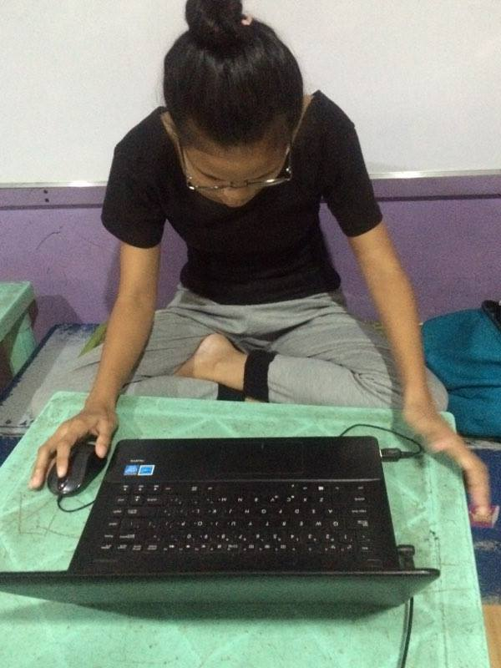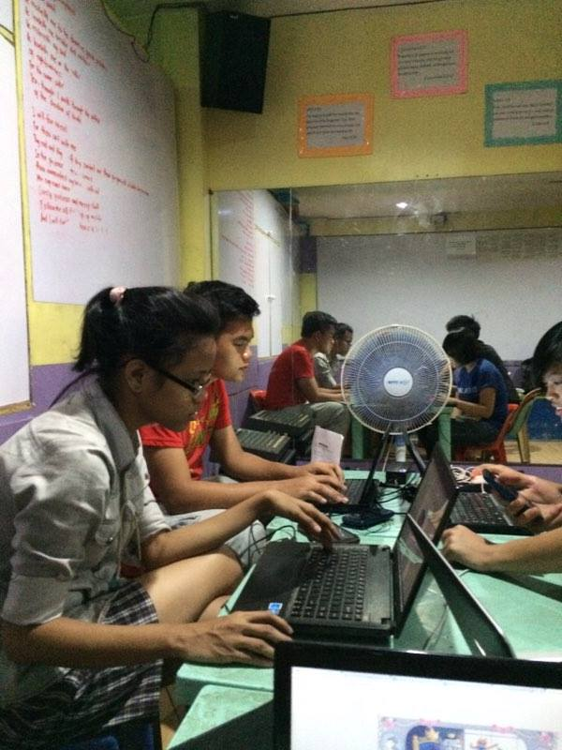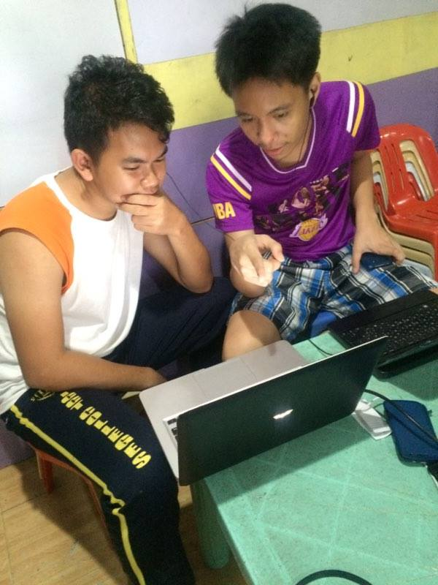

Photos: Development, Testing and Implementation Period

Photos: Development, Testing and Implementation Period

Photos: Development, Testing and Implementation Period

Photos: Development, Testing and Implementation Period

Appendix C

**Appendix C. Graphical User Interface**

**Graphical User Interface Screenshots**



Splash Screen

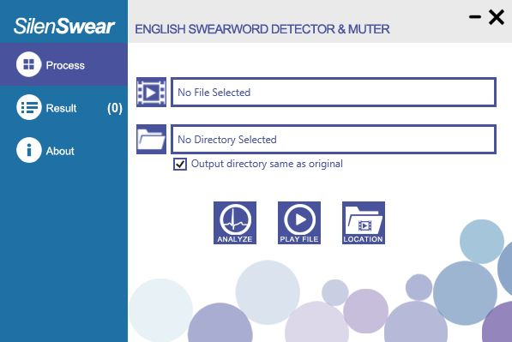

Main Window: Process Tab

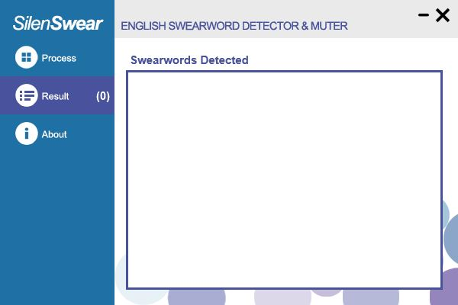

Main Window: Result Tab

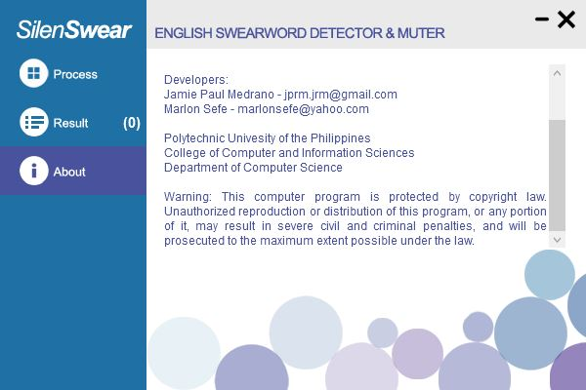

Main Window: About Tab

**How to Use:**

1. **Select video input:** In the ‘Process’ tab on the main window, click ‘Open File’ button to select an mp4 video to be analyzed.
2. **Select video output directory:** Select a directory where the generated video with muted swearwords will be saved by clicking the ‘Select Output Directory’ button. If the ‘Output directory same as original’ checkbox is ticked, the directory will be the same as the input.
3. **Start automatic swearword detection and muting:** Click the ‘Analyze’ button to start automatic swearword detection and muting in the input video file. After analysis, a new video file with muted swearwords will be generated. If no swearwords are detected, no video will be generated.
4. **Check detected swearwords:** Click the ‘Result’ tab to show all the detected swearwords from the video and the time of its occurrence.

CURRICULUM VITAE

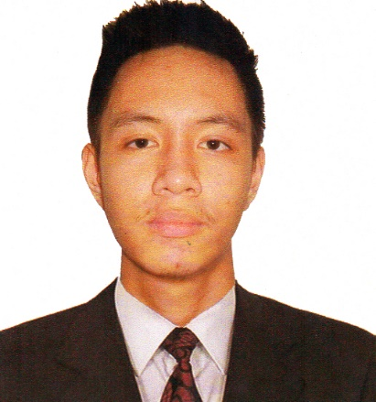**JAMIE PAUL R. MEDRANO**

3624 P. SANCHEZ ST. COR. PAT ANTONIO ST.

Sta. Mesa, Manila

+639256203685

jprm.jrm@gmail.com

|  |
| --- |
| **Personal data** |

**sex:** male  **citizenship:** filipino

**Birthday:** APRIL 12, 1996  **civil status:** single

**language spoken:** english and filipino **birthplace**: MANILA

**skills**

: Programming with C, Java, Visual C#, VB, SQL, HTML, CSS, PHP

: Graphic Design using Adobe Photoshop

: Video and Audio editing using Sony Vegas, Flash and Swishmax



**marlon m. sefe**

BLK. 39 P-6 LUPANG ARENDA, BRGY. STA. ANA

TAYTAY, RIZAL

09225393645

marlonsefe@yahoo.com

|  |
| --- |
| **Personal data** |

**sex:** male  **citizenship:** filipino

**Birthday:** march 31, 1996  **civil status:** single

**language spoken:** english and filipino **birthplace**: makati city

**skills**

: Proficient on MS Office (Word, PowerPoint, Access, Excel)

:Capable on Technical Documentation

:Has programming knowledge using C, C#, HTML, and Java



